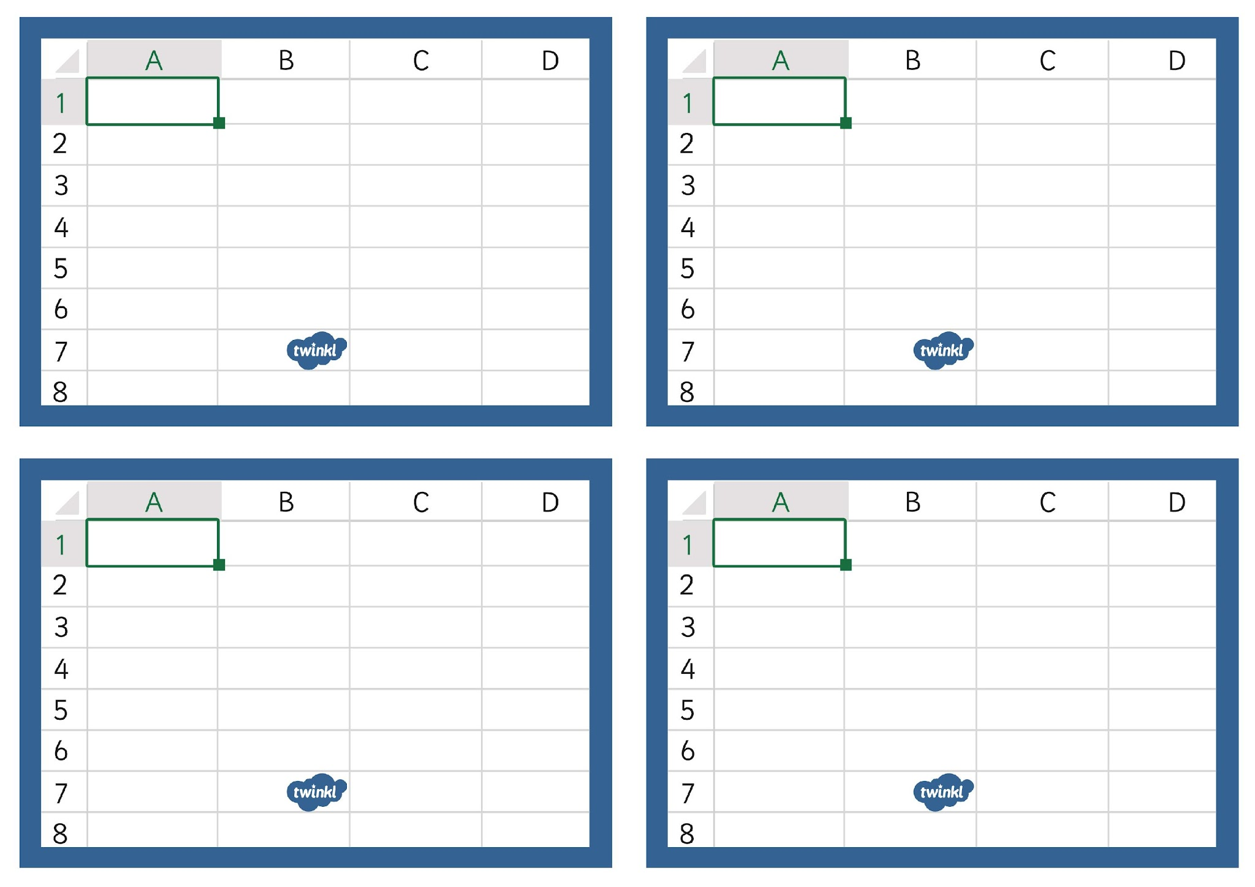
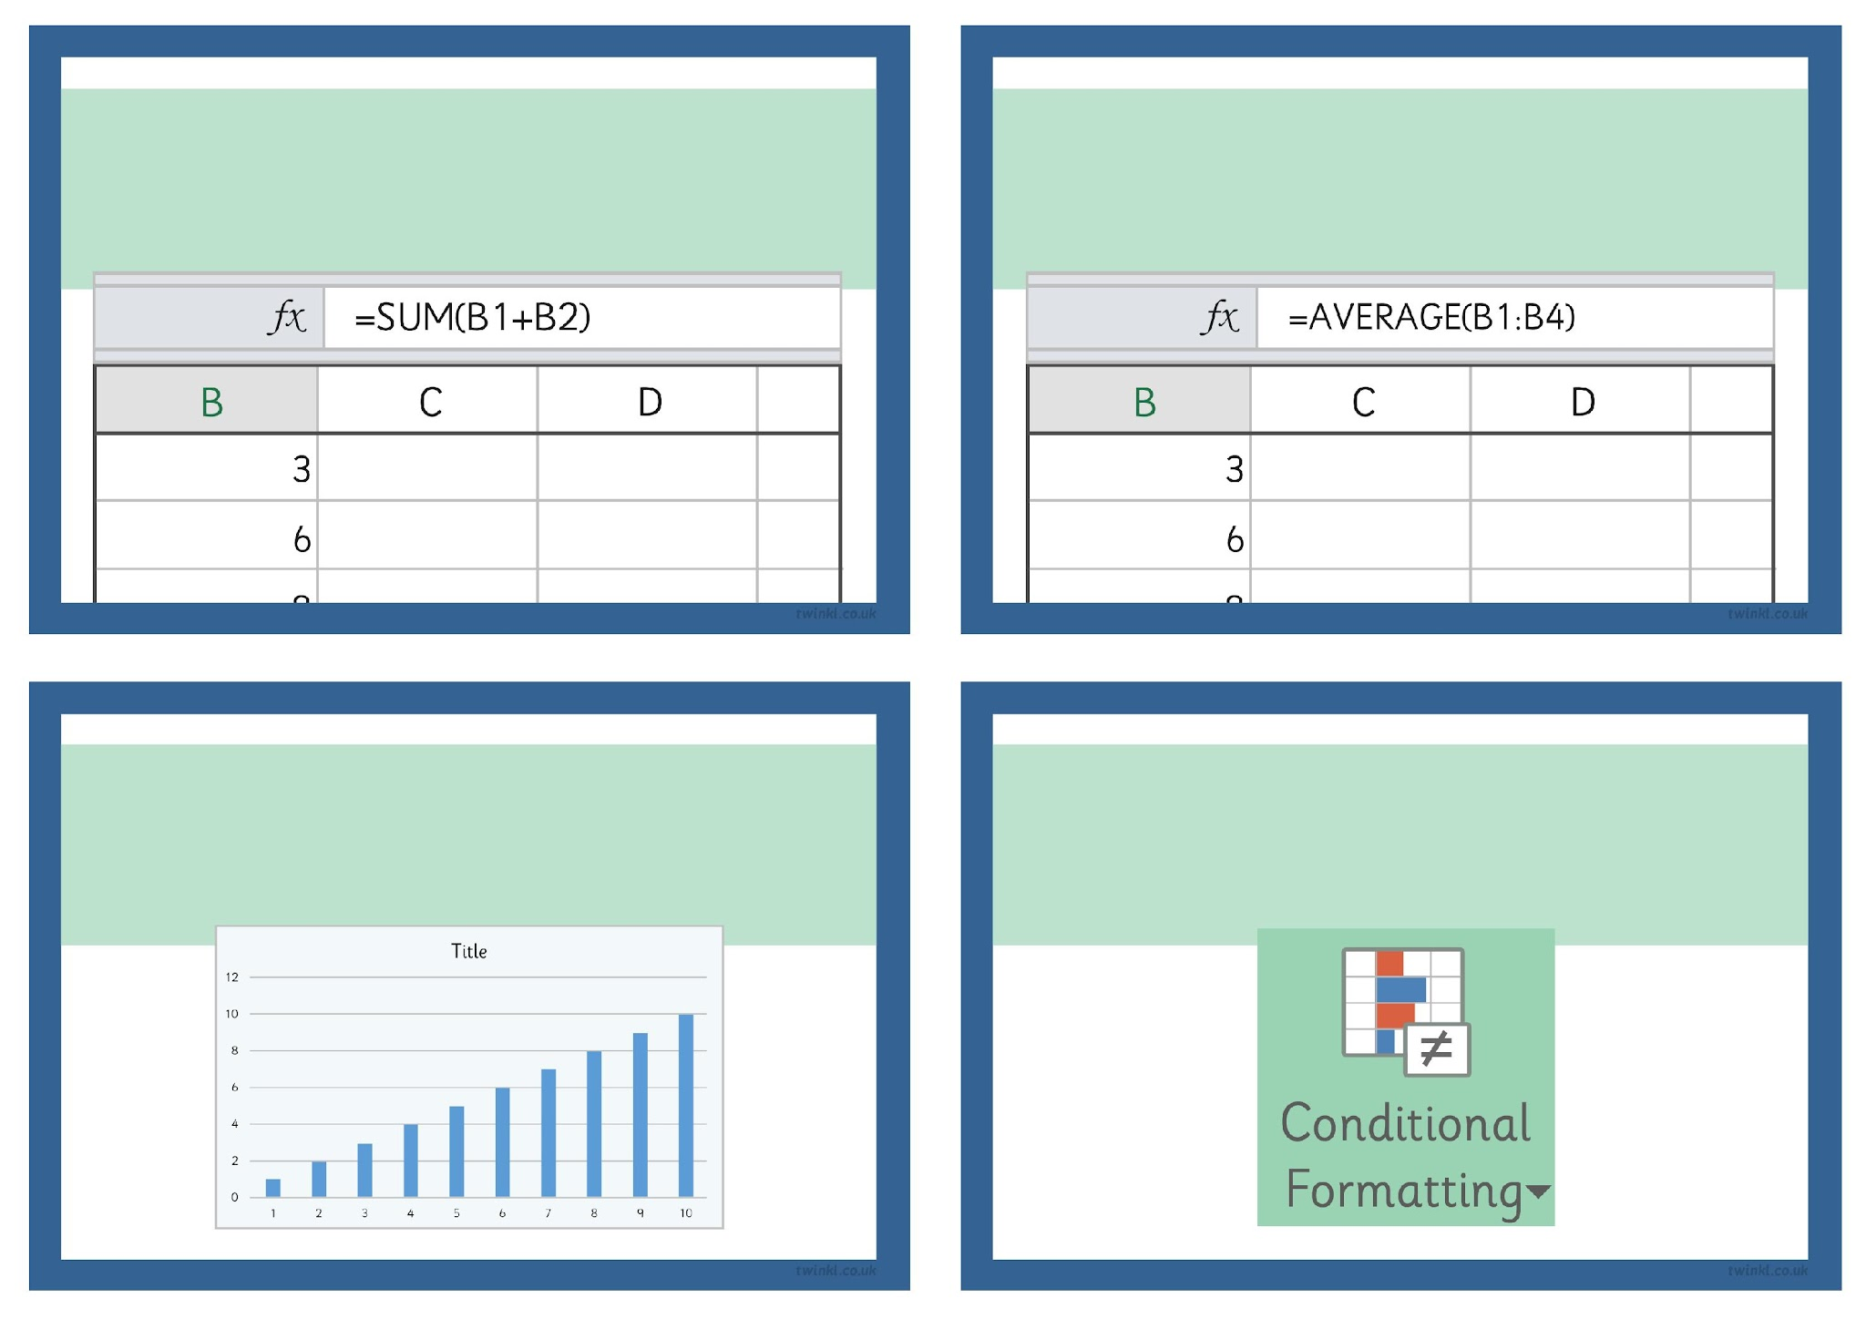
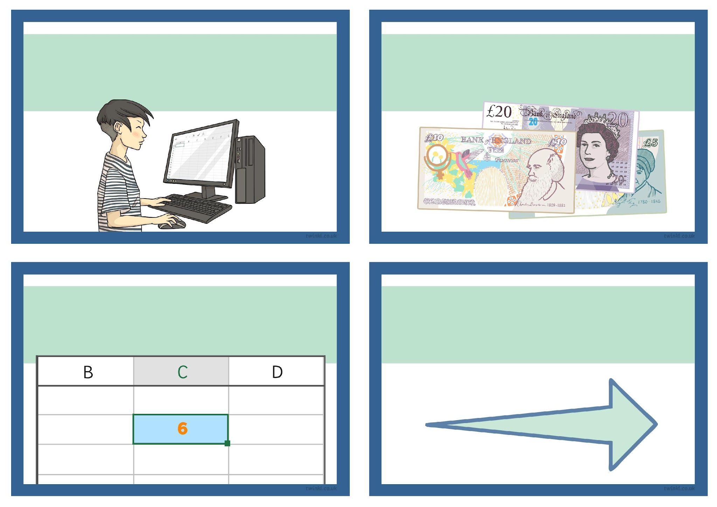
Spreadsheets
Challenge Cards

Spreadsheets
Challenge Cards

Spreadsheets
Challenge Cards

Spreadsheets
Challenge Cards

Can you format cells using theConditional Formatting tool?

Can you find the average of a set ofnumbers using the AVERAGE function?

Can you enter a formulausing the SUM function?

Can you insert and format anew graph for a set of data?

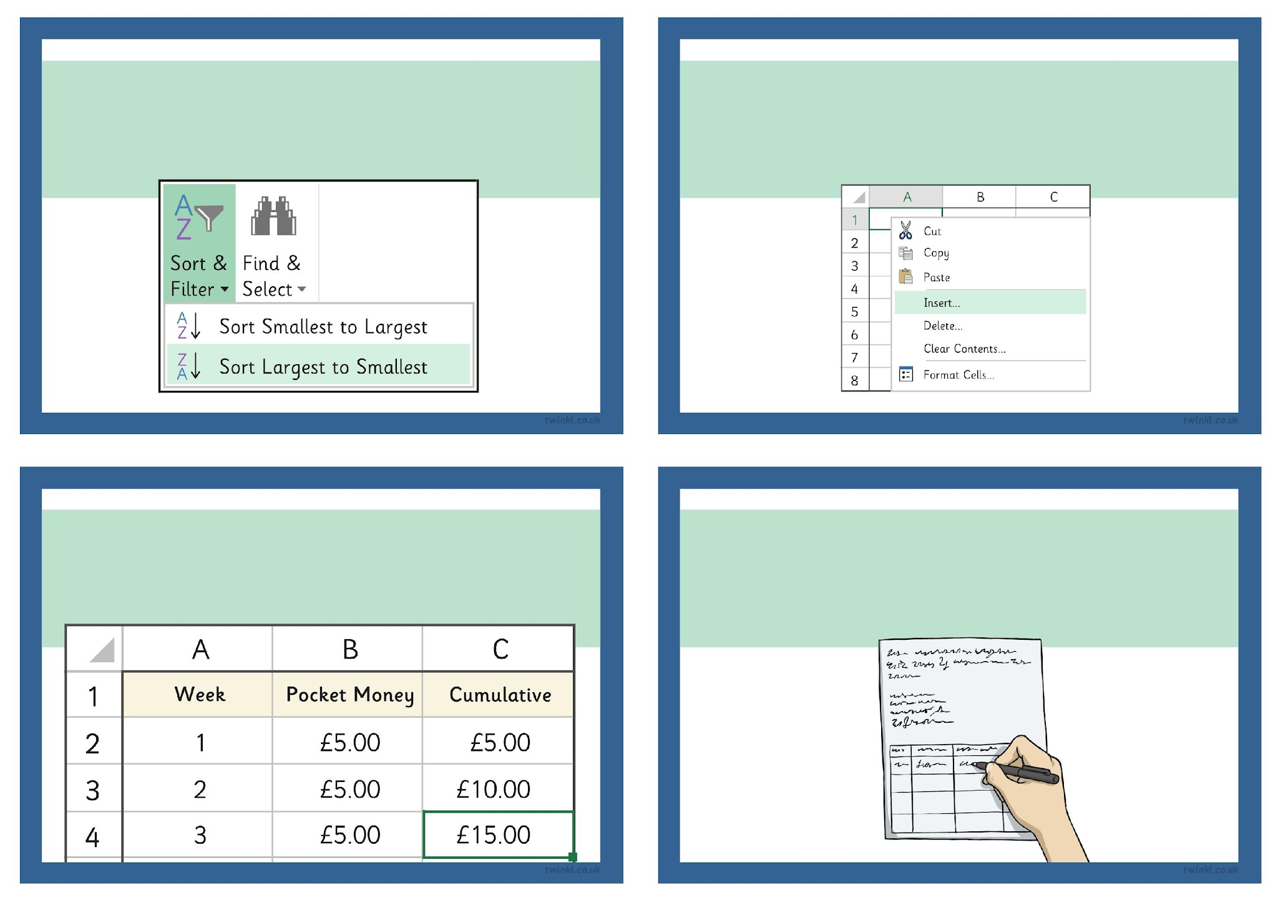
Can you design your ownspreadsheet for a specific purpose?

Can you use a spreadsheet tocalculate your own spending budget?

What does a ‘cumulative’ total mean?

How do you quickly copy a formula intomultiple cells? Write a set of instructionsfor someone who doesn’t know.

Can you insert new rows orcolumns to add information?

Can you sort data from largest to smallest?Can you sort text alphabetically?

Can you change the rowheight or column width?

Can you edit the formatting of thecolour, font, borders and alignment of a cell?

